

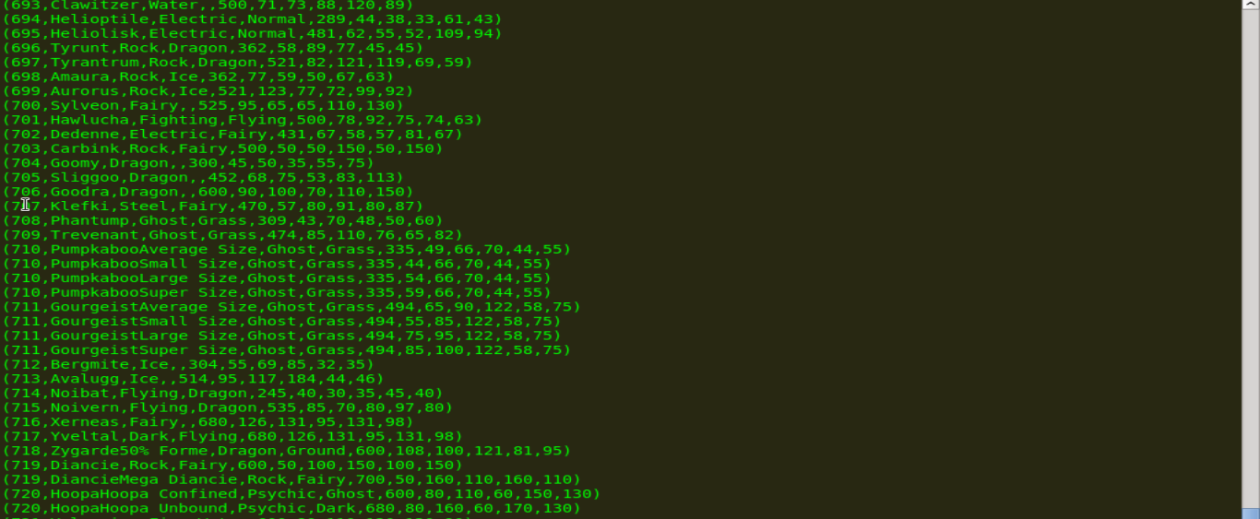

Usecase1:

**Ques 1: Find the list of players that have been selected in the qualifying round (DEFENCE>55).**



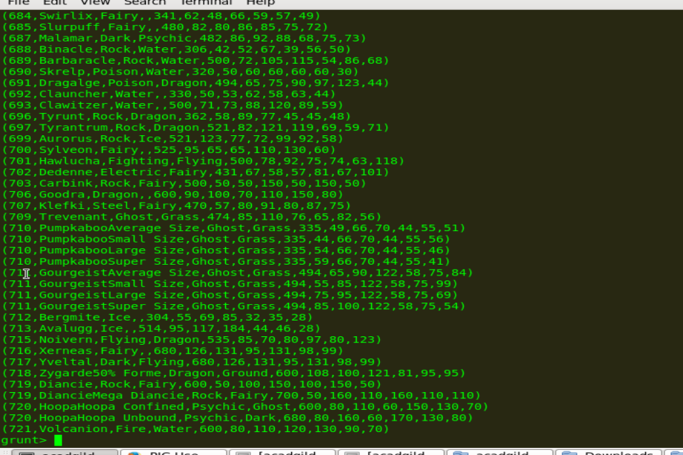

Usecase2 :

#### Ques 2: State the number of players taking part in the competition after getting selected in the qualifying round.





#### Ques 3: Using random() generate random numbers for each Pokémon on the selected list.



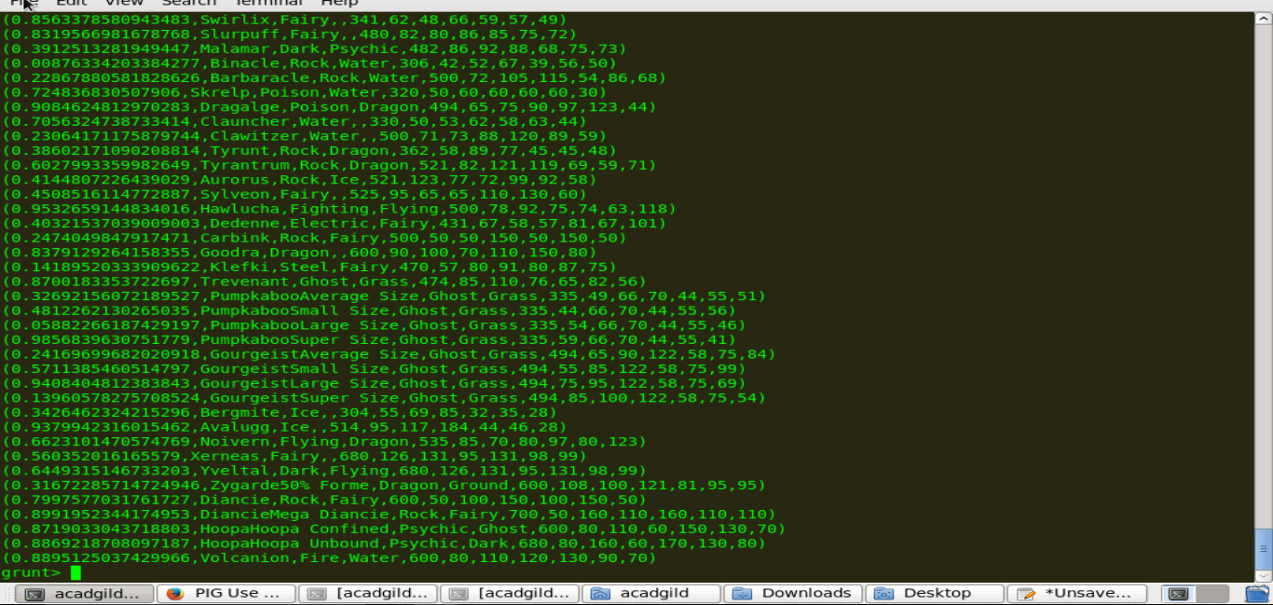

#### Ques 4: Arrange the new list in a descending order according to a column randomly.

#### 

#### 

#### 

#### Ques 5: Now on a new relation again associate random numbers for each Pokémon and arrange in descending order according to column random.

#### 

#### 

#### Ques: From the two different descending lists of random Pokémons, select the top 5 Pokémons for 2 different players.

#### 

#### 

#### 

#### 

#### Ques: Store the data on a local drive to announce for the final match. By the name player1 and player2 (only show the NAME and HP).



For player 1

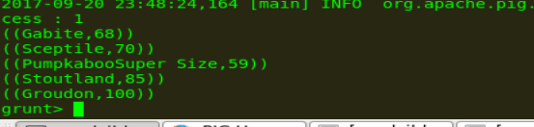



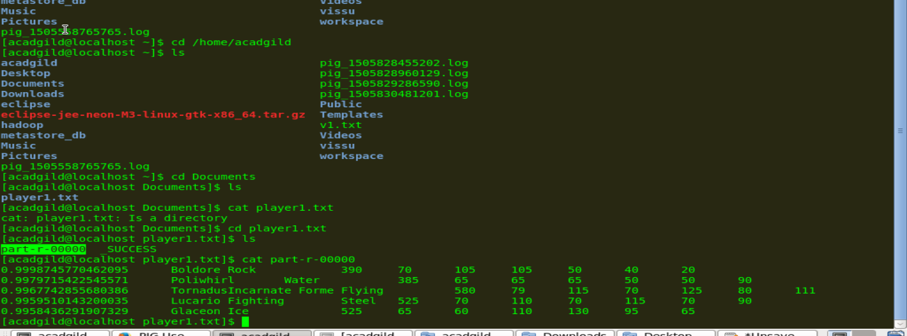



For player 2

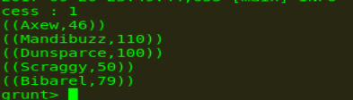

Therefore querying is over using some simple pre-defined functions to get 2 sets of 5 Pokémons, which get select randomly.

In conclusion, let’s store this result in our local system  so we can use it as input to our next blog. Especially relevant where we will see UDF using PIG and calculations will be done through user-defined formulas.